|  |
| --- |
|  |
| **ST. FRANCIS INSTITUTE OF TECHNOLOGY** |
| **PRAYAS 2019** |

|  |
| --- |
|  |

A PROJECT REPORT ON

**ULTRASONIC SENSOR**

SUBMITTED BY

**NAME CLASS & ROLL NO**

SIDDHESH DHOKE FE IT-B 703

MEDHA RAO KUMBLE FE IT-B 735

YASHODEEP PAWAR FE IT-B 729

PRAYAS which is an initiative by the First Year Engineering Students wherein we can showcase one’s innovative thinking and practical approach. It basically means transforming the knowledge which you have learnt into applications and sharing that with the peers.

This project is our first attempt towards creating a model on something related to what we have studied. PRAYAS which is conducted only for first year students helps them to come together and apply whatever you have learnt/learning in your First Year Engineering.

**ACKNOWLEDGEMENT**

We would take this opportunity to thank certain people who helped us with this project and guided us. We would like to express our thanks to the event co-ordinator Mr. Ravindra Garmode and the event co-coordinators Ms Arti Bhatnagar and Ms Deepa Panakkal . We would like to express our sincere gratitude towards our guide Ms Preeti Colaco . Also Ms Nidhi Tiwari and Mr. Sandeep Shetage who helped us a lot with our project .

**ABSTRACT**

Obstacle detector sensor detects any object, person, equipment, any stationary or moving object as it has a number of applications such as robotic movement control, vehicle control, blind man’s walking stick, medical applications, etc. Measurement using ultrasonic sensors is one of the cheapest among various options. In this project the obstacle detector by using ultrasonic sensor without a microcontroller is present.

**INDEX**

1. INTRODUCTION
2. SURVEY
3. COMPONENTS DESCRIPTION
4. METHODOLOGY
5. APPLICATIONS
6. RESULT
7. CONCLUSION

**LIST OF FIGURES**

1. HC-SR04 module
2. 555 Timer IC Block diagram
3. 555 Timer IC
4. Breadboard
5. Preset
6. Capacitor
7. Resistor
8. Regulator
9. Buzzer
10. Battery
11. Connecting wires
12. Circuit diagram

**LIST OF TABLES**

**1.** Ultrasonic Sensor Pin Configuration

**2.** Electrical parameters

**3.**Pin configuration of 555 timer IC

**INTRODUCTION**

Obstacle detecting sensor or knowing how far the objects is from /by the side of a moving entity is required in a large number of devices. These devices may be small or large also quite simple or complicated on how one designs it. Such sensors are available . They are divided as per their requirements . Low cost and accuracy as well as speed is important in most of the applications . In this project, we have made such an obstacle detecting sensor without using any microcontroller. These ultrasonic sensors can be used in a number of places for example to measure the distance between the object. Ultrasound waves are useful for both the air and underwater. These ultrasonic sensors are quite fast for most of the common applications.

**PROBLEM STATEMENT**

There are various devices which can determine the distance of the object using ultrasonic waves or devices working on IR sensors but the main limitation for the IR sensors is that they cannot work good in different light conditions and also cannot work in water hence to build a low cost system which could sense objects and which will work underwater and is not affected by varying light conditions. It does not work for transparent objects.

**NECESSITY OF PROJECT**

The main objective of this project is to provide a useful system which could detect objects which comes in its way.

**SYSTEM DESCRIPTION**

WORK RELATED COMPONENT SELECTION

1. Ultrasonic sensor HC-SR04
2. 555 Timer IC

**Ultrasonic Sensor HC-SR04**

Features

Ultrasonic ranging module HC-SR04 provides 2cm-400cm non-contact measurement function. The module includes ultrasonic transmitters, receiver and control circuit. The basic principle of the working is:

1. Using IO trigger for at least 10us high level signal
2. The module automatically sends eight 40 kHz and detect whether there is a pulse signal back.
3. If the signal back, through high level, time of high output IO duration is the time from sending ultrasonic

to returning.

Test distance=(high level time*velocity of sound(340m/s)/2)

**Wire connecting direct as following:**

* 5 v Supply
* Trigger Pulse Input
* Echo Pulse Output
* 0 V Ground

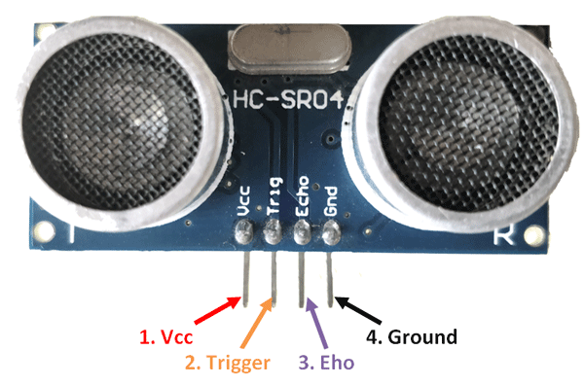

**Ultrasonic Sensor Pin Configuration**

|  |  |  |
| --- | --- | --- |
| **Pin Number** | **Pin Name** | **Description** |
| 1 | Vcc | The Vcc pin powers the sensor, typically with +5V |
| 2 | Trigger | Trigger pin is an Input pin. This pin has to be kept high for 10us to initialize measurement by sending US wave. |
| 3 | Echo | Echo pin is an Output pin. This pin goes high for a period of time which will be equal to the time taken for the US wave to return back to the sensor. |
| 4 | Ground | This pin is connected to the Ground of the system. |

**Electrical parameters**

|  |  |
| --- | --- |
| Working Voltage | DC 5 V |
| Working Current | 15 mA |
| Working Frequency | 40 Hz |
| Maximum Range | 4 m |
| Minimum Range | 2 cm |
| Measuring Angle | 15 degree |
| Trigger Input Signal | 10 us TTL pulse |
| Echo Output Signal | Input TTL lever signal and the range in proportion |
| Dimensions | 45*20*15 mm |

555 Timer IC

The [555 timer](https://electronicsforu.com/videos-slideshows/diy-ne555-timer-circuit) IC is an integral part of electronics projects. Be it a simple project involving a single 8-bit micro-controller and some peripherals or a complex one involving system on chips (SoCs), 555 timer working is involved. These provide time delays, as an oscillator and as a flip-flop element among other applications.

Depending on the manufacturer, the standard 555 timer package includes 25 transistors, 2 diodes and 15 resistors on a silicon chip installed in an 8-pin mini dual-in-line package (DIP-8). Variants consist of combining multiple chips on one board. However, 555 is still the most popular. Let us look at the pin diagram to have an idea about the timer IC before we talk about 555 timer working.

## Some important features of the 555 timer:

## 555 timer is used in almost every electronic circuit today. For a 555 timer working as a [flip flop](https://electronicsforu.com/resources/learn-electronics/flip-flop-rs-jk-t-d) or as a multi-vibrator, it has a particular set of configurations. Some of the major features of the 555 timer would be,

* It operates from a wide range of power ranging from +5 Volts to +18 Volts supply voltage.
* Sinking or sourcing 200 mA of load current.
* The external components should be selected properly so that the timing intervals can be made into several minutes along with the frequencies exceeding several hundred kilohertz.
* The output of a 555 timer can drive a transistor-transistor logic (TTL) due to its high current output.
* It has a temperature stability of 50 parts per million (ppm) per degree Celsius change in temperature which is equivalent to 0.005 %/ °C.
* The duty cycle of the timer is adjustable.
* Also, the maximum power dissipation per package is 600 mW and its trigger and reset inputs has logic compatibility.

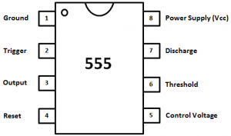

|  |  |  |
| --- | --- | --- |
| **Pin** | **Name** | **Purpose** |
| 1 | GND | Ground reference voltage, low level (0 V) |
| 2 | TRIG | The OUT pin goes high and a timing interval starts when this input falls below 1/2 of CTRL voltage (which is typically 1/3 *V*cc, CTRL being 2/3 *V*cc by default if CTRL is left open). In other words, OUT is high as long as the trigger low. Output of the timer totally depends upon the amplitude of the external trigger voltage applied to this pin. |
| 3 | OUT | This output is driven to approximately 1.7 V below +*V*cc, or to GND. |
| 4 | RESET | A timing interval may be reset by driving this input to GND, but the timing does not begin again until RESET rises above approximately 0.7 volts. Overrides TRIG which overrides threshold. |
| 5 | CTRL | Provides “control” access to the internal voltage divider (by default, 2/3 *V*cc). |
| 6 | THR | The timing (OUT high) interval ends when the voltage at threshold is greater than that at CTRL (2/3 *V*cc if CTRL is open). |
| 7 | DIS | Open collector output which may discharge a capacitor between intervals. In phase with output. |
| 8 | *V*cc | Positive supply voltage, which is usually between 3 and 15 V depending on the variation. |

## Working

The 555 generally operates in 3 modes:

1. A-stable
2. Mono-stable
3. Bi-stable modes.

### Astable mode

This means there will be no stable level at the output. So the output will be swinging between high and low. This character of unstable output is used as a clock or square wave output for many applications.

### Mono-stable mode

This configuration consists of one stable and one unstable state. The stable state can be chosen either high or low by the user. If the stable output is set at high (1), the output of the timer is high (1). At the application of an interrupt, the timer output turns low (0). Since the low state is unstable it goes to high (1) automatically after the interrupt passes. Similar is the case for a low stable [monostable mode](https://electronicsforu.com/videos-slideshows/setup-555-timer-circuit-monostable-mode).

### Bi-stable mode

In bistable mode, both the output states are stable. At each interrupt, the output changes from low (0) to high (1) and vice versa, and stays there. For example, if we have a high (1) output, it will go low(0) once it receives an interrupt and stays low (0) till the next interrupt changes the status.

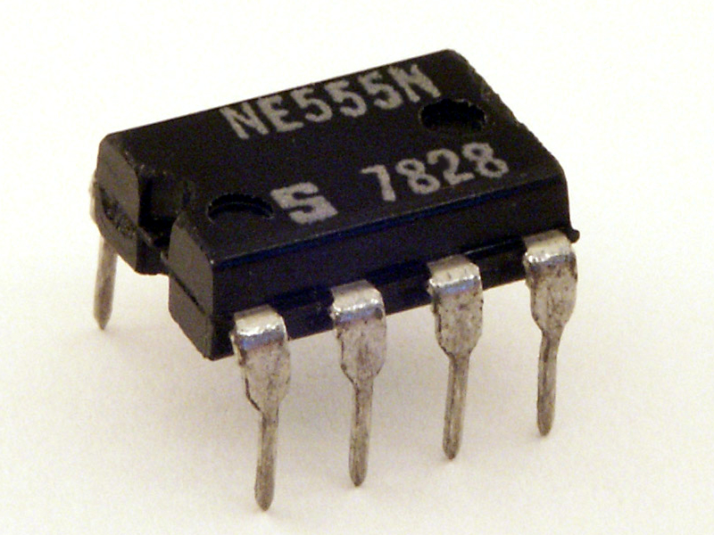

**BASIC COMPONENTS**

1. Breadboard
2. Preset
3. Capacitor
4. Resistor
5. Voltage Regulator
6. Buzzer

7. Battery

8. Connecting Wires

**Breadboard**

A breadboard is a solderless device for temporary prototype with electronics and test circuit designs. Most electronic components in electronic circuits can be interconnected by inserting their leads or terminals into the holes and then making connections through wires where appropriate. The breadboard has strips of metal underneath the board and connect the holes on the top of the board. The metal strips are laid out as shown below. Note that the top and bottom rows of holes are connected horizontally and split in the middle while the remaining holes are connected vertically.

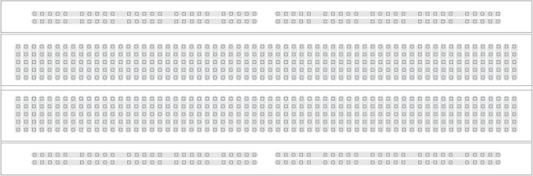

**Preset**

A preset is a three legged electronic component which can be made to offer varying resistance in a circuit. The resistance is varied by adjusting the rotary control over it. The adjustment can be done by using a small screw driver or a similar tool. The resistance does not vary linearly but rather varies in exponential or logarithmic manner. Such variable resistors are commonly used for adjusting sensitivity along with a sensor.The variable resistance is obtained across the single terminal at front and one of the two other terminals. The two legs at back offer fixed resistance which is divided by the front leg. So whenever only the back terminals are used, a preset acts as a fixed resistor. Presets are specified by their fixed value resistance.

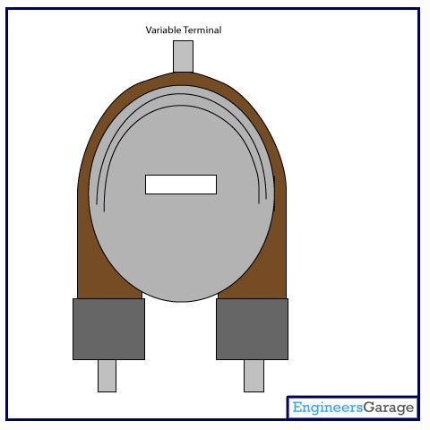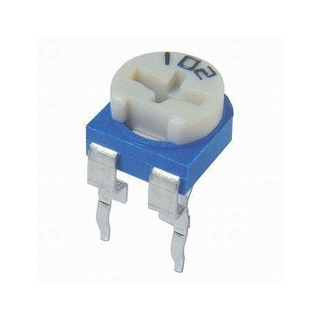

**Capacitor**

Capacitor is an electronic component that stores [electric charge](https://www.rapidtables.com/electric/electric_charge.html). The capacitor is made of 2 close conductors (usually plates) that are separated by a dielectric material. The plates accumulate electric charge when connected to power source. One plate accumulates positive charge and the other plate accumulates negative charge.

The capacitance is the amount of electric charge that is stored in the capacitor at voltage of 1 Volt.

The capacitance is measured in units of [Farad](https://www.rapidtables.com/electric/farad.html) (F).

The capacitor disconnects current in direct current (DC) circuits and short circuit in alternating current (AC) circuits.

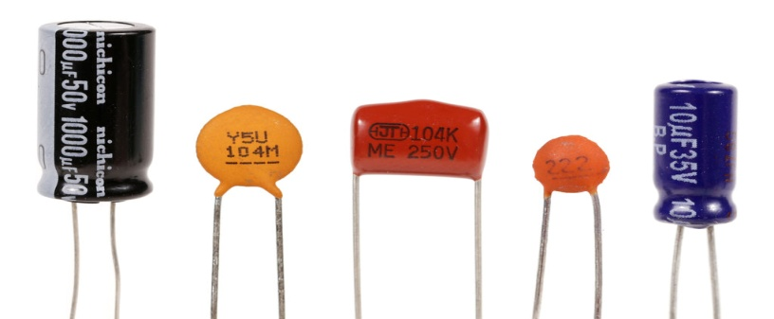

**Resistor**

The resistor is a passive electrical component to create resistance in the flow of electric current. In almost all electrical networks and electronic circuits they can be found. The resistance is measured in ohms. An ohm is the resistance that occurs when a current of one ampere passes through a resistor with a one volt drop across its terminals. The current is proportional to the voltage across the terminal ends.

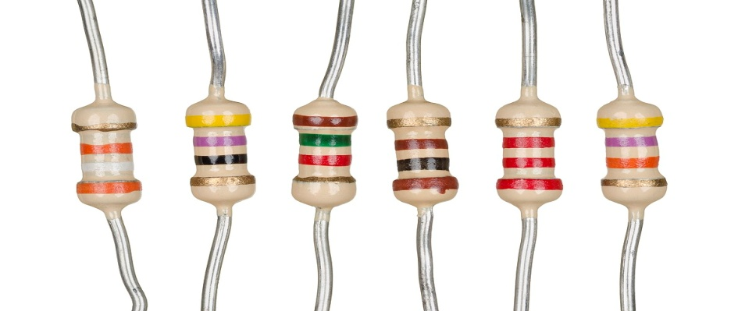

**Regulator**

 voltage regulator, a low drop positive regulator with a 3.3V fixed output voltage. This fixed regulator provides a great amount of stability and protection, with its on chip trimming this regulator is able to reach an output voltage tolerance within ±1%. Each one of these voltage regulators can output a max current of 800mA.

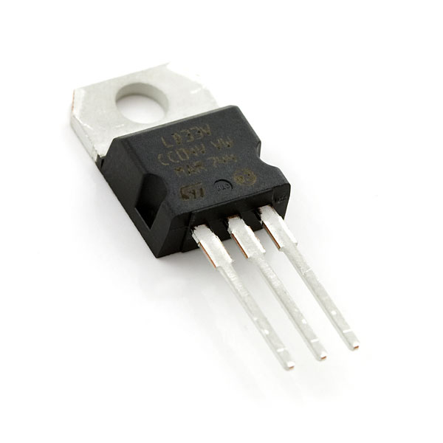

**Buzzer**

A **buzzer** or **beeper** is an [audio](https://en.wikipedia.org/wiki/Sound) signalling device,[[1]](https://en.wikipedia.org/wiki/Buzzer#cite_note-1) which may be [mechanical](https://en.wikipedia.org/wiki/Machine), [electromechanical](https://en.wikipedia.org/wiki/Electromechanics), or [piezoelectric](https://en.wikipedia.org/wiki/Piezoelectricity) (*piezo* for short). Typical uses of buzzers and beepers include [alarm devices](https://en.wikipedia.org/wiki/Alarm_devices), [timers](https://en.wikipedia.org/wiki/Timer), and confirmation of user input such as a mouse click or keystroke.

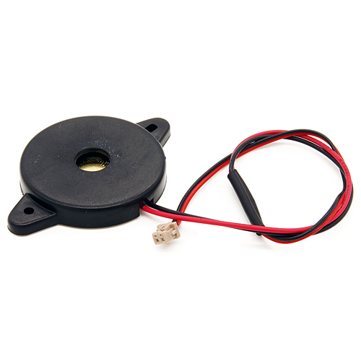

**Battery**

Thebattery, is a common size of battery that was introduced for the early [transistor radios](https://en.wikipedia.org/wiki/Transistor_radio). It has a rectangular prism shape with rounded edges and a polarized snap connector at the top.

**Connecting Wires**

Connecting wires allows an electrical current to travel from one point on a circuit to another because electricity needs a medium through which it can move. Most of the connecting wires are made up of copper or aluminium. Copper is cheap and good conductivity. Instead of the copper, we can also use silver which has high [**conductivity**](https://buddymantra.in/active-component-transistors/) but it is too costly to use.

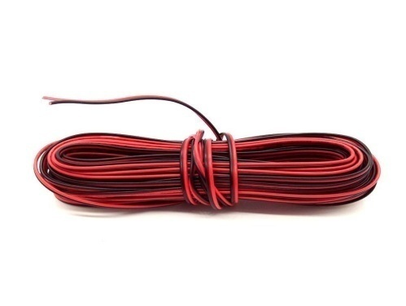

**METHODOLOGY**

Ultrasonic detection is most commonly used in industrial applications to detect hidden tracks, discontinuities in metals, composites, plastics, ceramics, and for water level detection. For this purpose the laws of physics which are indicating the propagation of sound waves through solid materials have been used since ultrasonic sensors using sound instead of light for detection.

For sending sound waves and receiving echo, ultrasonic sensors, normally called transceivers or transducers will be used. They work on a principle similar to radar that will convert electrical energy into mechanical energy in the form of sound, and vice versa.

### Operation of ultrasonic sensors:

When an electrical pulse of high voltage is applied to the ultrasonic transducer it vibrates across a specific spectrum of frequencies and generates a burst of sound waves. Whenever any obstacle comes ahead of the ultrasonic sensor the sound waves will reflect back in the form of echo and generates an electric pulse. It calculates the time taken between sending sound waves and receiving echo. The echo patterns will be compared with the patterns of sound waves to determine detected signal’s condition.

Ultrasonic obstacle sensor consists of a set of ultrasonic receiver and transmitter which operate at the same frequency. The point when the something moves in the zone secured the circuit’s fine offset is aggravated and the buzzer/alarm is triggered.

[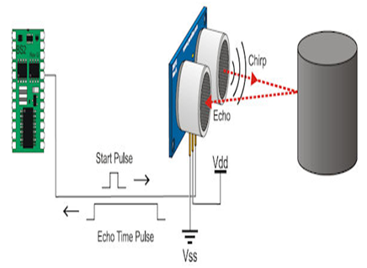](https://www.elprocus.com/wp-content/uploads/2013/08/Ultrasonic.png)

Circuit diagram:

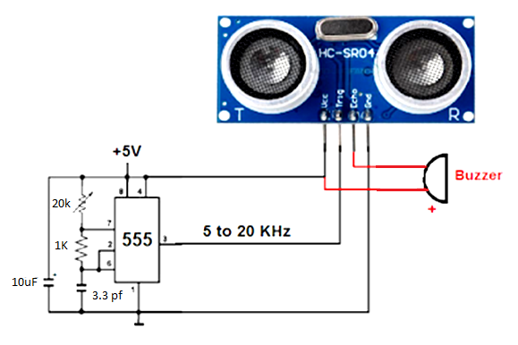

**Working of Circuit:**

When the circuit is switched ON a voltage of 9V flows through the circuit. The 7905 Voltage regulator IC drops the voltage to 5V which later flows throughout the circuit evenly. Here the 555 timer IC works in astable mode which is obtained by connecting terminal 4 to terminal 8 (POWER SUPPLY to RESET pin) and by connecting the terminal 2 to terminal 6 ie. TRIGGER to THRESHOLD. The terminal 7 is connected to 20K preset. 1K resistor is connected between terminal 6 and terminal 7. 3.3 pf is connected from terminal 6 to ground. One end of the preset is connected to the positive of the 10uF and the negative is connected to the ground. Now from the HC-SR04 the VCC pin is connected to the voltage source and also to the positive of the buzzer. The TRIGGER pin is then connected to the terminal 3 of the 555 Timer IC . The ECHO pin is connected to the negative of the buzzer and finally the GND pin is connected to the ground of the breadboard.

When a 9V supply is given because of the 7905 voltage regulator IC the voltage is dropped to 5V. Thus the circuit receives a 5V supply. The OUTPUT pin of the 555Timer IC gives the input to the TRIG pin of the HC-SR04.Because of the 555 Timer IC the signal sent are in the form of cycle. The 555 Timer IC regulates the time interval between two signals. The ECHO pin also known as the output pin of the HC-SR04 which is connected to the buzzer which then creates a sound thus detecting an object. The object distance from which the sensor detects an object can be changed by varying the values of the preset.

**APPLICATIONS:**

* Distance measurement
* Production line sensor
* Thread or wire break detection
* Advanced parking assistance
* Stacking height control
* Robotic sensing

**RESULT:**

The working model of the proposed ultrasonic sensor without the arduino was successfully designed and implemented. The performance of the circuit was analysed for different conditions. The ultrasonic module works fine.

**CONCLUSION:**

The objective of this project was to design and implement an Ultrasonic object detecting sensor. As described in this report a system was developed which can detect any objects. Hence we can make following conclusions:

* The system can detect objects with sufficient accuracy
* This offers a low cost and efficient solution for object detecting sensor
* This is simple as there was no use of micro-controller(Arduino).

